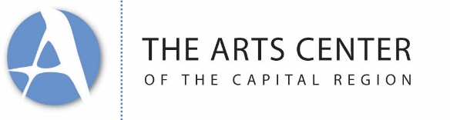

June 20, 2022
Job Title: Curator for Public Art and Placemaking
Category: Full Time Salary, Exempt
Location: Troy, NY

The Arts Center of the Capital Region is a multifaceted arts organization that supports and facilitates community arts engagement; we teach, exhibit, train, and connect. One of our fastest growing program areas is public art and placemaking. We are the City of Troy’s partner for public art, involved in state-wide and city-based initiatives, and highly committed to developing new community and artist interactions.

The successful candidate will start with some exciting projects in development, while others will be entirely envisioned. Current projects include the Troy Glo Light Installation Festival and the Fish Market Community Engagement project, both of which can be found on www.artscenteronline.org.

The successful candidate will be required to live in the Capital Region and work in Troy; the candidate will only occasionally be able work from a remote location.

Responsibilities:

- Collaborate with staff, stakeholders, and communities to understand the needs and opportunities in Troy and the Capital Region.

- Work generatively to develop relevant opportunities for public art and placemaking projects in concert with a public art committee comprised of board and community members.

- Participate in fundraising, manage budgets, source competitive pricing, and be a responsible steward of donated funds.

- Partner with a small staff to develop programming synergies, be open and willing to pitch in as needed.

ACCR believes in the 40-hour work week and encourages staff to manage their workload to achieve a healthy work-life balance. As with all creative jobs, projects can be exciting, energizing, and stressful as deadlines approach and vision reaches fruition. The successful applicant will be able to manage these moments and ask for help when needed.

Qualifications: Five to ten years of direct experience in the arts, developing, leading, and completing multiple concurrent projects is required. Direct experience in public art and placement is highly encouraged.

Compensation: Between $45,000-$55,000 dependent on above qualifications.

Four weeks PTO, five additional sick days, all federal holidays, as well as an end of year paid break. ACCR pays a % of heath care and has several options, from 100%-paid base level insurance, to higher level plans for those who desire those. A moving allowance will be offered (up to $5,000).

Process: ACCR is an equal opportunity employer and welcomes all applications to: elizabeth@artscenteronline.org. Please send a cover letter expressing why you want to work in placemaking & public art in Troy; your resume and relevant writing samples.

